  The School of Technology

BSc (Hons) in Software Engineering
(Batch – 08)

Collaborative Development

(5CS024)

PROJECT OVERVIEW REPORT

Medhani Niwoda – Project Manager
Student Number- 2502384

01.Introduction
ORYN Campus Hub is a fully functional web-based application that was created by a group of six students working together as a team on the 5CS024 Collaborative Software Development module. The project aimed at solving a very startling issue, which students have to deal with daily at university frustration trying to make a booking in various disconnected systems and find out about the events or refer to a bus schedule. ORYN unites all that in the same roof.

The team adopted the name ORYN to show that it was a single center of opportunity a one-stop destination where a student can find all they required in campus. Its vision is simple: when a student needs to go to some place, he/she must only log in and then in the same interface, he/she can book a facility, enroll on a sports event, look at the menu of a cafe, borrow a library book, join a club or track a campus bus. No longer the need to switch between systems, no longer will there be the use of paper forms and occasions when opportunities are missed just because they were difficult to locate.

Sprint 1 was dedicated to the implementation of a functional MVP which indicates the main architecture and a set of main features. The backend has been written in the code bare using Node.js and Express and linked with a MySQL database and JWT authentication and bcrypt password hashing are already implemented. The frontend has 16 HTML pages each one is related to one of the many campus services all linked to the same backend API. This report records on what has been constructed, the method used to construct the same, and the direction the project is moving.

MVP Video :
https://drive.google.com/drive/folders/1m4RgOz87aQRCz4njhCxIE4ueHcoR8xuJ?usp=sharing

Team Members & Roles

Name | Role | Primary Responsibilities
Medhani Niwoda | Project Manager | Sprint planning, Jira, Basecamp, risk management, GitHub oversight
Pulindu Balasooriya | Backend Developer | Node.js/Express server, REST API, MySQL, JWT auth, bcrypt, Stripe
Saduni Priyalakshi | Frontend Developer | All 16 HTML/CSS/JS pages, responsive UI, frontend-backend integration
Dewmi Umegha | QA Tester | Test cases, bug reporting, cross-browser testing, QA log
Udara Nethmi | Database Administrator | MySQL schema design, table relationships, seed data
Ginuka Weragoda | Business Analyst | Requirements, user stories, Moscow prioritization, investor pitch narrative

02. Project Overview
ORYN Campus Hub is not a simple booking system. It is intended to be the digital pulse on a college campus in this century - a vehicle that links students to services, to one another and to opportunities. The long-term vision: The smart campus ecosystem The long term vision is that all student interactions, whether it be checking out a textbook or being at a club meeting is being seamlessly monitored, rewarded and made frictionless.

The foundation was what was constructed during Sprint 1. The team decided to take the long-term view and invest in getting the architecture right, by implementing proper authentication, clean API design, good database structure, and a system to reward all the efforts, instead of rushing to implement the features and later on the team had to rebuild the architecture. This was a premeditated move. The shaky foundation has led to Sprint 2 being a two-fold workload as the project manager explained during the sprint retrospective.

2.1 Modules Delivered — Sprint 1
Module | Description | Status
Student Registration | Full registration form with bcrypt hashing, field validation, duplicate detection | Done
Student Login | JWT token authentication, 7-day session, last-login tracking | Done
Facility Booking | Book sports halls, labs, study rooms with time-conflict detection | Done
Campus Events | Browse events, register, cancel, track remaining spots | Done
Digital Library | Browse books, borrow with 14-day due dates, +50 rewards points | Done
ORYN Café | View menu, place orders, earn points (Rs.50 = 1 point) | Done
Fitness Centre | Book gym classes, earn +30 points per session | Done
Clubs & Societies | Browse clubs, join, leave, update roles, member tracking | Done
Campus Transit | Bus schedules, share live location, earn +5 points | Done
Rewards System | Points earn/redeem across all modules, transaction log | Done
Marketplace | List items, browse listings, message sellers | Done
Careers Board | Browse job/internship listings, submit applications | Done
Campus Map | Interactive campus navigation page | Done
Social Feedback | Student feedback and social interaction module | Done
About & Home Portal | Landing page linking all campus services | Done

03. Technology Stack
Three priorities guided the technology choices for ORYN: an architecture that would scale cleanly into Sprint 2 and beyond, tools that reflect industry-standard practices so the project has real portfolio value, and practical skills the team already possessed or could quickly develop.

3.1 Backend
Technology | Version | Purpose
Node.js | v16+ | JavaScript runtime — server-side logic and API handling
Express.js | v5.2.1 | Web framework — routing, middleware, HTTP request/response
MySQL2 | v3.20.0 | Database client — parameterized queries, connection management
bcrypt | v6.0.0 | Password hashing — secure credential storage with salt rounds
jsonwebtoken | v9.0.3 | JWT authentication — stateless session tokens
dotenv | v17.3.1 | Environment variables — keeps secrets out of source code
cors | v2.8.6 | CORS policy — controlled cross-origin access from frontend
multer | v2.1.1 | File upload handling — for resume/CV uploads in Careers module
stripe | v20.4.1 | Payment processing — future marketplace transactions

3.2 Frontend
Technology | Usage
HTML5 | Page structure, semantic and form Markup 16 pages.
CSS3 | CSS variables (custom properties), animations, grid responsive, glass morphism.
JavaScript (ES6+) | DOM, form validation and dynamic content generation Backend Fetch API.
Google Fonts | Inter, Plus Jakarta Sans, Fraunces, Playfair Display - similar typography on every page.

3.3 Database
DBA Udara Nethmi focused on data integrity, referential consistency, and future extensibility when designing the MySQL relational database. To ensure data accuracy at the database level as well as the application level, the schema makes use of foreign key relationships.

Table | Key Fields & Relationships
users | id, first_name, last_name, index_no (UNIQUE), email (UNIQUE), username (UNIQUE), password (bcrypt), reward_points, role, last login
events | id, name, event_date, max_participants, current_registrations, points_awarded, category
event_registrations | user_id, event_id , status (confirmed/cancelled), attendees
facilities | id, name, category, capacity, location, is_available
facility_bookings | user_id (FK), facility_id (FK), booking_date, start_time, end_time, purpose
clubs | id, club_name, category, member_count, description
club_members | user_id (FK), club_id (FK), role (president/secretary/member), status (active/inactive)
library_books | id, title, author, isbn, category, total_copies, available_copies
library_borrowings | user_id (FK), book_id (FK), borrow_date, due_date, return_date
reward_transactions | user_id (FK), points (+/-), reason, created_at
gym_classes / gym_bookings | Class scheduling and student booking with capacity tracking
transit_buses / transit_schedules | Bus routes, departure/arrival times, day_type (weekday/weekend)
marketplace_listings | user_id (FK), title, category, price, condition, status
cafe_orders / cafe_order_items | Order management with itemised breakdown and points calculation

04.System Workflow & Architecture
ORYN is a classic 3-level architecture and includes a presentation (HTML pages), an application (Node.js / Express REST API), and a data layer (MySQL database). The frontend and backend are linked by the means of the Http and the Fetch API, and the information is positioned in the form of a JSON. The authentication status is managed through JWT token storage on the browser in the session Storage.

4.1 System Architecture Overview
The flow chart below will be grounded on the manner in which a normal interaction between a student and the system operates in ORYN. Applying to the example of the event registration flow: The student is going to fill out a form on the Events.html, the POST request would be sent to /api/events/register. The server within the Express authenticates the request, compares the identity of the student with the JWT token, performs a database query of the capacity and ongoing registrations, and inserts the new registration record, updates the number of events and provides a JSON response, and the front-end displays a success message.

FRONT-END  16 HTML Pages  HTML · CSS · JavaScript | BACKEND API  Node.js + Express  JWT · bcrypt · CORS | DATABASE  MySQL 8.0  14 tables · FK constraints
• Student fills in form  • Fetch API sends JSON  • Displays server response | • Validates request body  • Verifies JWT token  • Queries DB + returns JSON | • Stores/retrieves records  • Enforces FK constraints  • Manages transactions

05. Project Management Approach
Being in charge of a six-person software project is hard - and the team experienced it directly, especially during the initial week. Various individuals have different pace of work, expectations, and the way they communicate is not the same. The project management process was required to be organized in a manner that would ensure that all members of the project management team were at the same level without being too rigid that would slow down the real development process.

5.1 Agile Sprint Methodology

5.2 Tools Used
Tool | How It Was Used
Jira | Epics, user stories and subtasks Sprint board. The activities were allocated an owner, approximate effort and a due date. Used in the team to determine the speed of the sprints by the team members.
Trello | To Do / In Progress / Done Visual Kanban board to view the daily tasks. Supplemented Jira with the team members who were more comfortable with scanning it.
Basecamp | Central communication center-- here all the official decisions, agendas of meetings and action items as well as file sharing was done. Created database that was searchable on all decisions that were made by the teams.
GitHub | Branch feature strategy of source control. Each work was done on feature branches, which were merged through pull request and needed to contain at least one reviewer. Main branch did not update until before demos.
Excel | Sprint progress tracker updated after every stand up - percentage of task completion, blockers, and ownership in each individual.
Google Forms | Inventory survey to the members at the start of each week - received progress, blockers and availability. The following stand-up agenda was informed by responses.

5.3 Git Branching Strategy
The project manager had to implement the agreed-upon process for the project kick-off meeting and then begin with the sprint phase. The process in question was called the "branching strategy," which was a very straightforward rule: The main branch was considered sacred, while the development branch was used as an integration branch, i.e., all feature branches will be combined here via Pull Request (PR) after they completed their code reviews.

e.g.
- main = main (contains stable and is demo ready), managed by PM - only can be pushed into right before by PM
- dev = development/integration branch; where all feature branches will be blended together via PR after doing code reviews.
- feature/[name] = 1 feature (ex. feature/registration-api, feature/clubs-ui).
- fix/[name] = branches to fix bugs that were discovered by QA related to that feature.

The first week was full of 2 direct pushes made to the main branch, both causing integration issues that did not get resolved until hours later. The rest of the sprint had no other incidents related to pushes to the main branch and the following PR was extremely multiply executed.

06. project class diagram

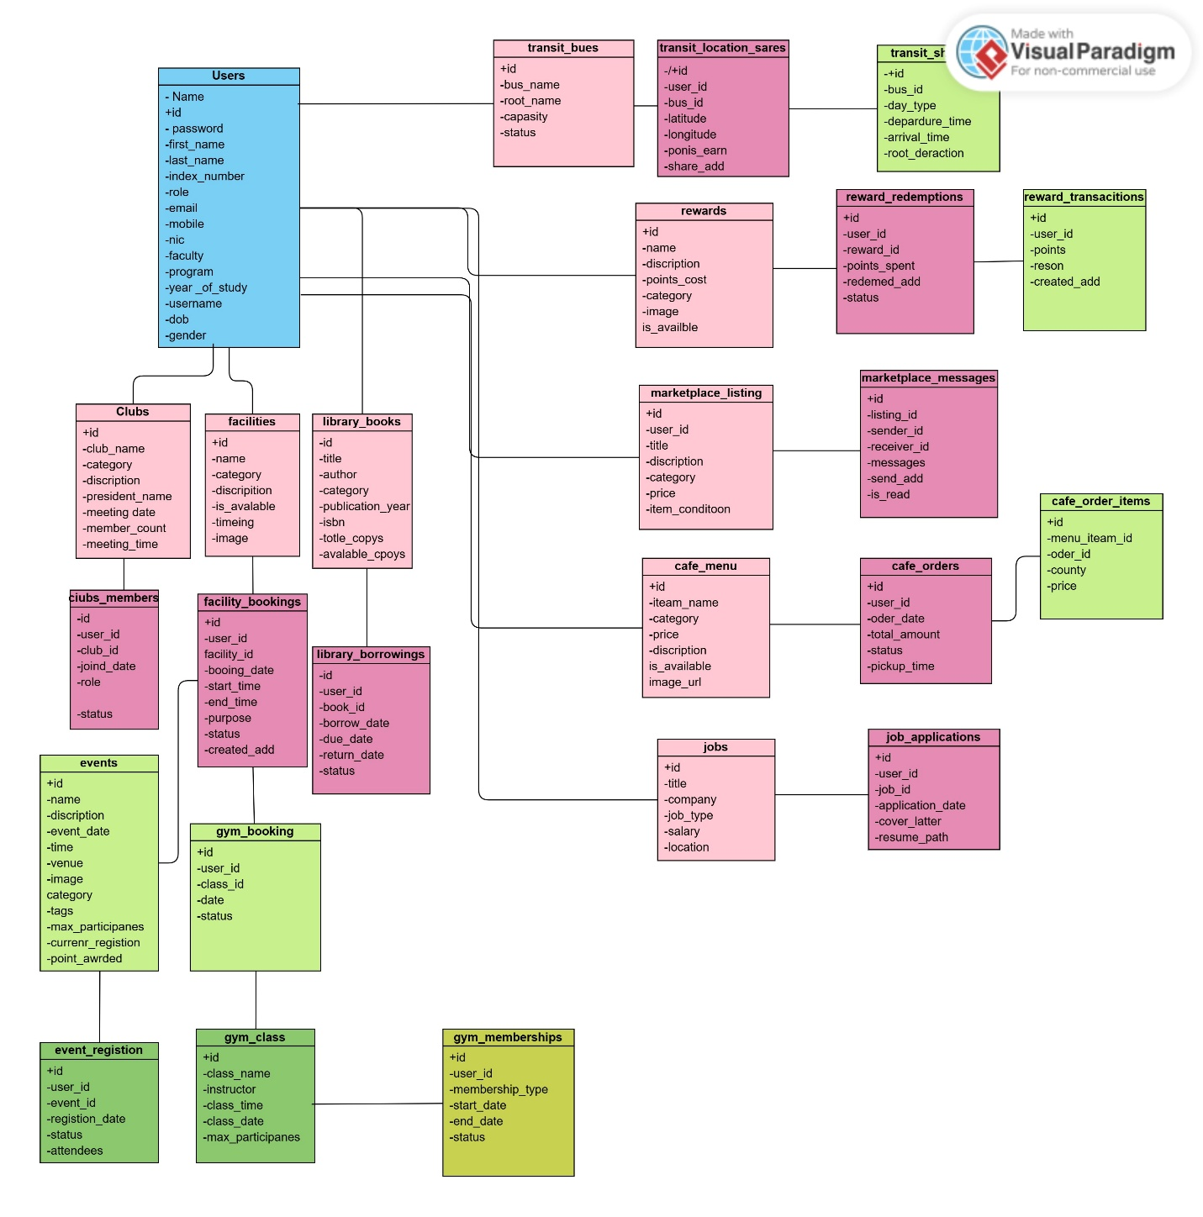

07. project flow chart

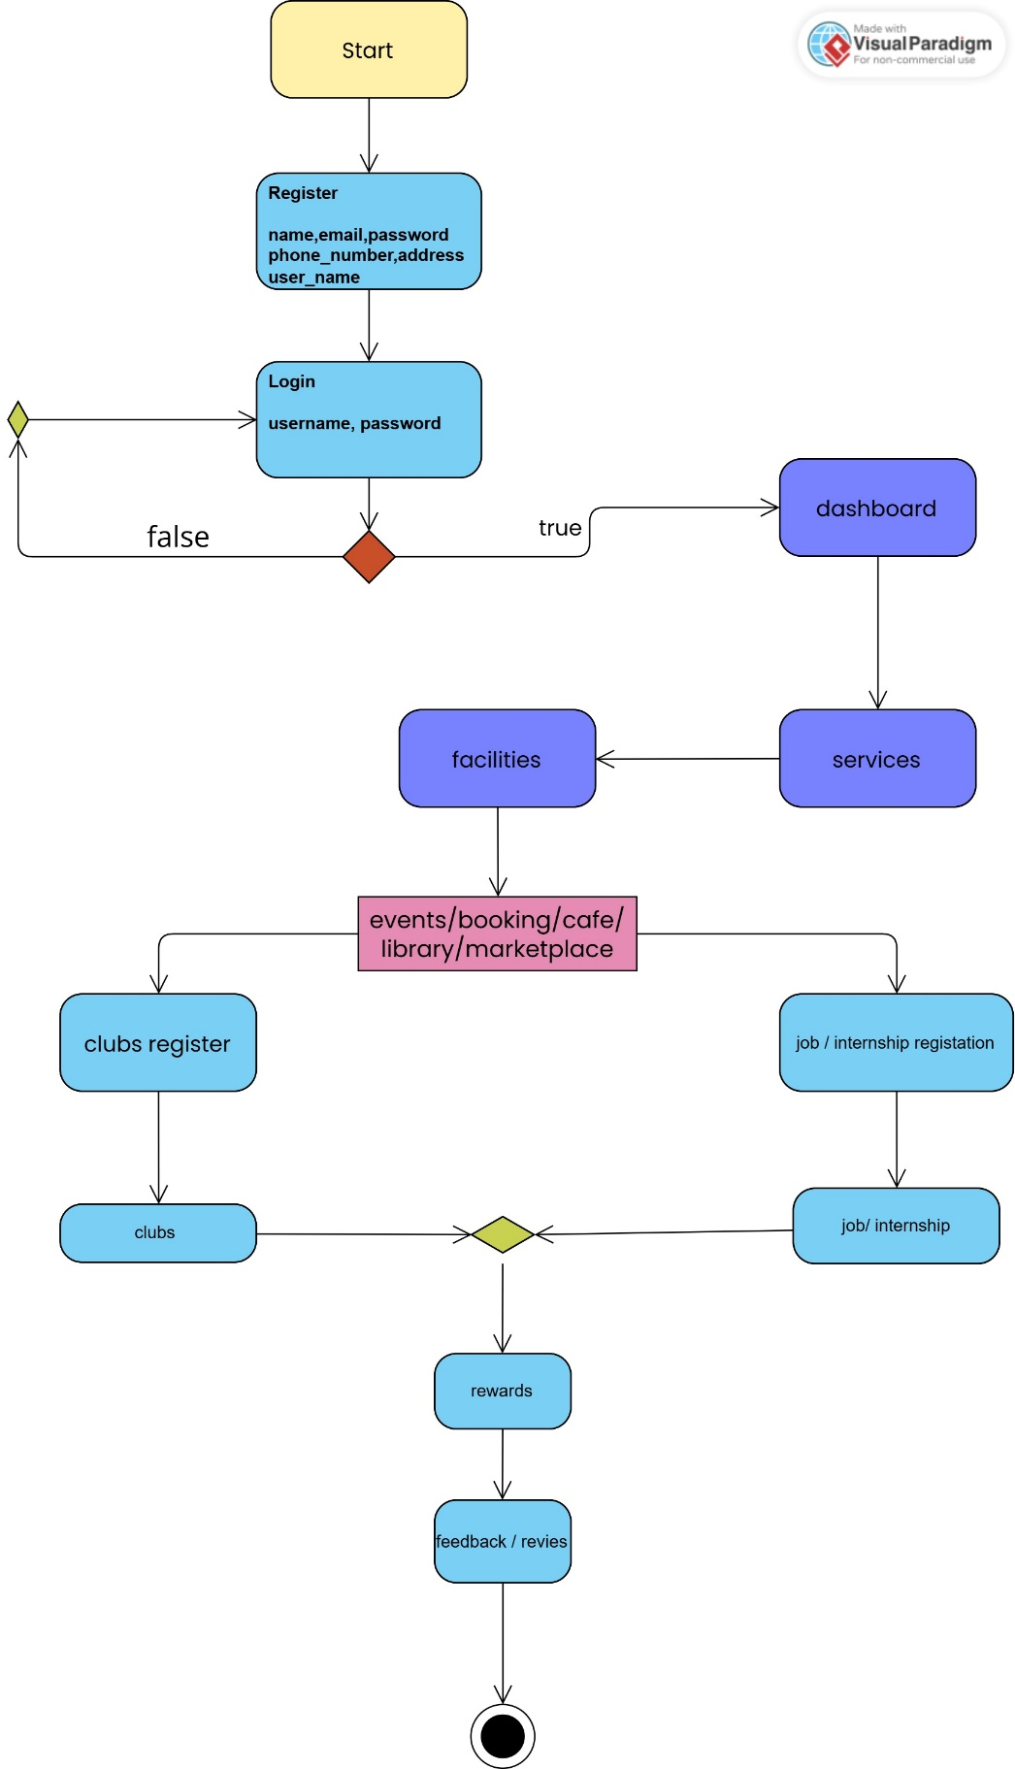

08. My role in this project

My Contribution to this Project as a Project Manager.

In this project, the Project Manager was myself, and in this instance, my role was to organize the overall process of development as well as coordinate it. My major role was to ensure that the project activities were properly laid down and within the set schedule. I initiated the process of assigning the work among the team members based on their individual abilities and monitored the performance of the team over the course of the sprint.

I used project management tools such as Trello and Jira to track the workflow and the tasks and Basecamp to communicate and exchange updates with the team. My other habit was to visit the project repository on GitHub to ensure that all were working fine and that there was good version control.

I also assisted in getting communication within the team, resolving small scale conflicts and ensuring everyone was focused on what the project was meant to accomplish. The position allowed me to develop leadership and time management and organizational skills and maintain the project on track.

08. Conclusion
The first part of the ORYN Campus Hub is. It is really good. The ORYN Campus Hub has done more than what was needed to be called a product. It has a foundation that can be made bigger later. The sixteen front parts are. The back part has many ways to do things. The database is set up with fourteen tables that work together. The ORYN Campus Hub uses a way to keep user passwords safe from the start. A rewards program is ready to work with all the parts. The Stripe payment system is ready to be used when the next part starts.

The team had problems to solve. Some of these problems were about the technology. Some were about people. One of the problems was making the API plan. The team should have made this plan earlier. The team made a plan for working but it took an extra week to get it right. Some team members had much work to do which caused problems with the data.. The whole team worked together to find and talk about these problems. Now the team is ready to start the part in a better place, than when they started the first part.

The ORYN Campus Hub that the team made is something they can all be proud of. The ORYN Campus Hub is a thing that was made with careful planning by a team of six people. They learned what it means to work to make software. The ORYN Campus Hub is a product that the team is happy to have maddens.

